IMPORTANT INFORMATION ABOUT YOUR DRINKING WATER
Dear Water Customer: Today's Date:

This notice contains important information about your water service and may affect your rights. The water system does not have record of your service line. All service lines that are unknown will be identified as suspected lead service lines. We encourage you to have this notice translated in full into a language you understand and before you make any decisions that may be required under this notice.

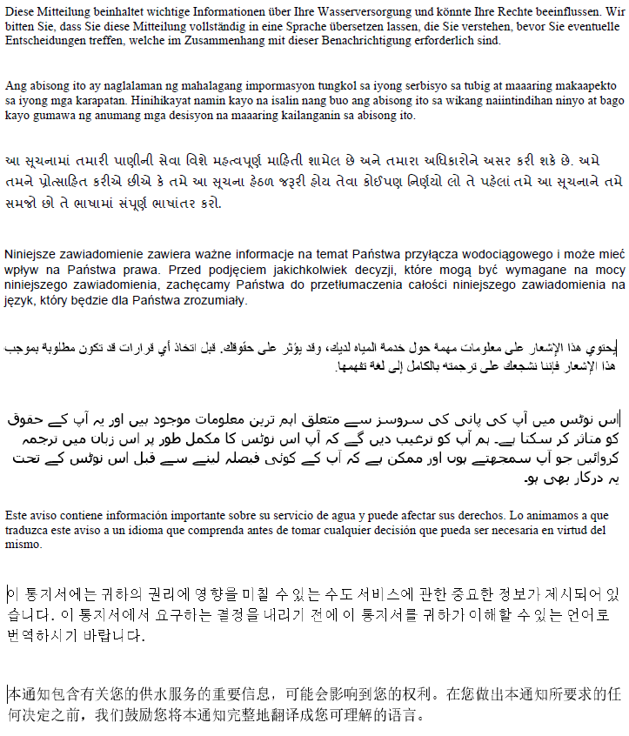

YOU ARE SERVED BY AN UNKNOWN MATERIAL SERVICE LINE THAT MAY CONTAIN LEAD
Health Effects of Lead

Exposure to lead in drinking water can cause serious health effects in all age groups. Infants and children can have decreases in IQ and attention span. Lead exposure can lead to new learning and behavior problems or exacerbate existing learning and behavior problems. The children of women who are exposed to lead before or during pregnancy can have increased risk of these adverse health effects. Adults can have increased risks of heart disease, high blood pressure, kidney, or nervous system problems. The most common exposure to lead is swallowing or breathing in lead paint chips and dust. However, lead in drinking water can also be a source of lead exposure. In the past, lead was used in some water service lines and household plumbing materials. Lead in water usually occurs through corrosion of plumbing products containing lead; however, disruption (construction or maintenance) of lead service lines may also temporarily increase lead levels in the water supply. This disruption may be sometimes caused by water main maintenance/replacement.

Work on your service line may result in sediment, possibly contains lead from the service line in the building’s water.

Below describes some information about the project and some preventative measures you can take to help reduce the amount of lead in drinking water.

What you can do to reduce lead exposure in drinking water:

- Run your water to flush out lead. If the plumbing in your home is accessible; you may be able to inspect your own plumbing to determine whether you have a lead service line or lead solder. Otherwise, you will most likely have to hire a plumber.
  - If you do not have a lead service line, running the water for 1 – 2 minutes at the kitchen tap should clear the lead from your household plumbing to the kitchen tap. Once you have done this, fill a container with water and store it in the refrigerator for drinking, cooking, and preparing baby formula throughout the day.
  - If you do have a lead service line, flushing times can vary based on the length of your lead service line and the plumbing configuration in your home. The length of lead service lines varies considerably. Flushing for at least 3 – 5 minutes is recommended.
- Use cold water for drinking, cooking, and preparing baby formula. Do not cook with or drink water from the hot water tap, lead dissolves more easily into hot water. Do not use water from the hot water tap to make baby formula.
- Look for alternative sources or treatment of water. You may want to consider purchasing bottled water or a water filter that is certified to remove "total lead".
- Clean and remove any debris from faucet aerators on a regular basis.
- Do not boil water to remove lead. Boiling water will not reduce lead.
- Purchase lead-free faucets and plumbing components.
- Remove the entire lead service line.
- Please Call : ___________________ for information on our lead service line replacement program. Including any programs available that may provide financing solutions to assist property owners to replace the customer-owned portion of a lead service line.
- The supplier must replace the supplier-owned portion of a lead service line when the property owner notifies the supplier that the owner will replace the customer-owned portion of the lead service line.

- Test your water for lead. Verify your service line. Please call us to find out how to get your water tested for lead.
- If test results indicate a lead level above 15 ug/L, bottled water should be used by pregnant women, breast-feeding women, young children, and formula-fed infants.

